OptiSigns – OptiBot Mini-Clone Take-Home Test
— ship it in ~ 10 focused hours. Everything else is extra credit.

0 . Warm-up (15 min)

- Create a free optisigns.com trial account and chat with OptiBot so you know what you’re cloning.
- Open a free platform.openai.com account.
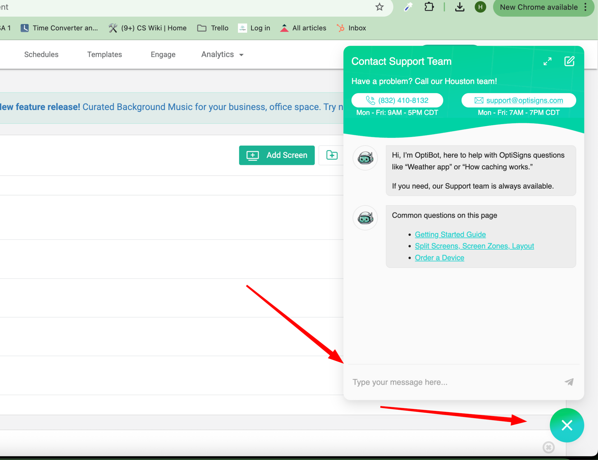

1 . Scrape ⇒ Markdown (~3 h)

Goal: prove you can ingest messy web content and normalize it.

- Pull ≥ 30 articles from support.optisigns.com.
- Convert each article to clean Markdown.
- Save each file as <slug>.md (or whatever scheme you like).
- Preserve relative links, code blocks, and headings. Remove nav/ads.

Hint: you can use Zendesk API to read the article,

2 . Build Assistant & Programmatically Load Vector Store (~2 h) API upload is mandatory—no UI drag-and-drop here.
Create the Assistant – Easiest way is to use OpenAI Playground UI. System prompt (verbatim):
You are OptiBot, the customer-support bot for OptiSigns.com.
- Tone: helpful, factual, concise.
- Only answer using the uploaded docs.
- Max 5 bullet points; else link to the doc.
- Cite up to 3 "Article URL:" lines per reply.

  - Via Python script, upload Markdown files to OpenAI Vector Store files via OpenAI API.
    - Upload files to OpenAI
    - Attach files to Vector Stores
    - Chunking strategy is up to you; just explain it in the README.
    - Log how many files and chunks were embedded.

  - Quick sanity check – Jump into the Playground, attach the Assistant, and ask: “How do I add a YouTube video?”
Take a screenshot showing a correct answer with citations.

You can learn more about the overall OpenAI Agent here.

  - Deploy Scraper as Daily Job (~2 h)

- Wrap your scraper-uploader in main.py.
- Dockerize (Dockerfile).
- Schedule it to run once per day on DigitalOcean Platform
- Job must:
  - Re-scrape.
  - Detects new/updated articles (hash, Last-Modified, etc.).
  - Upload only the delta.

Log counts: added, updated, skipped. Provide a link to job logs or last run artefact.

Deliverables

Item | Must Have
GitHub repo | Please DO NOT name your github repo “optisigns” something, just give it cryptic name so future candidate not easy to find when search optisigns  Clear commits; no hard-coded keys (use .env.sample).
Dockerfile | docker run -e OPENAI_API_KEY=... main.py runs once and exits 0.
README (≤ 1  page) | - setup• how to run locally• link to daily job logs• screenshot of Playground answer
Screenshot | Assistant correctly answers sample questions with cited URLs.

Grading (70 pts pass bar)

Area | Pts
Scrape & clean quality | 25
API-based vector-store upload works | 20
Daily job deployment & logs | 15
Code clarity + README | 10
(Bonus tests) | +5

Set up 1h Project Reviews:
We will discuss
- Your overall concept understanding of the project
- Your approach, solution
- How do you learn something new like this if you haven’t learned it before
- Your thoughts, suggestions on how OptiBots can be improved, what potential challenges you think we will be facing

